Chapter 9:
Reports

Objectives

After completing this section, you will be able to:

- View Reports
- Build and Edit Reports
- Schedule Reports to send to Users and Access Groups

Contents
Reports 263
How to View a Report 264
How to Filter Criteria 265
How to Create/Edit a Report 266
Report Detail Links 267
Designer 267
Sorting 271
Parameters 272
Subscriptions 273
To Activate/Deactivate a Subscription 274
Permissions 275
Copy Report 276
View SQL or RDL 276

Table of Figures

Figure 1 Report Browser 263
Figure 2 User Report Parameters Screen 264
Figure 3 Example of a Report Rendered in Html 264
Figure 4 Parameter Detail Screen 265
Figure 5 Report Viewer Toolbar 265
Figure 6 New Report Detail Screen 266
Figure 7 Report Designer Screen 267
Figure 8 Expression Builder Screen 267
Figure 9 Report Designer - Groups Screen 268
Figure 10 Report Group Detail Screen 268
Figure 11 Report Group Detail Screen 269
Figure 12 Report Groups Viewer 269
Figure 13 Report Designer - Columns Screen 270
Figure 14 Report Column Detail Screen 270
Figure 15 Report Sorting Screen 271
Figure 16 Report Parameters Screen 272
Figure 17 Report Parameter Detail Screen 272
Figure 18 Subscription Detail Screen 273
Figure 20 Report Permissions Screen 275
Figure 21 Example of Report to Replicate 277

Reports

The Reports Module allows the user to add, edit, delete, and assign customized Reports to other Users. This module can be accessed via Go To from the Task Bar or the appropriate Menu Group.
The reports are organized via a folder tree. The first two branch folders are always Private and Shared. A User who creates a report (or is assigned as owner of the report) and keeps the Permissions of the report “Private” will have his/her reports located in the Private folder. No one else (except an Administrator) has access to this report. Any report that is designated as “Shared” within Permissions will be available in the Shared folder to those Users or Access Groups that have specific permission to view and/or edit it.
The second and third branch folders are named or selected during the creation or editing of a report. When a report is moved from Private to Shared, the second and third branch folders are moved along with it.

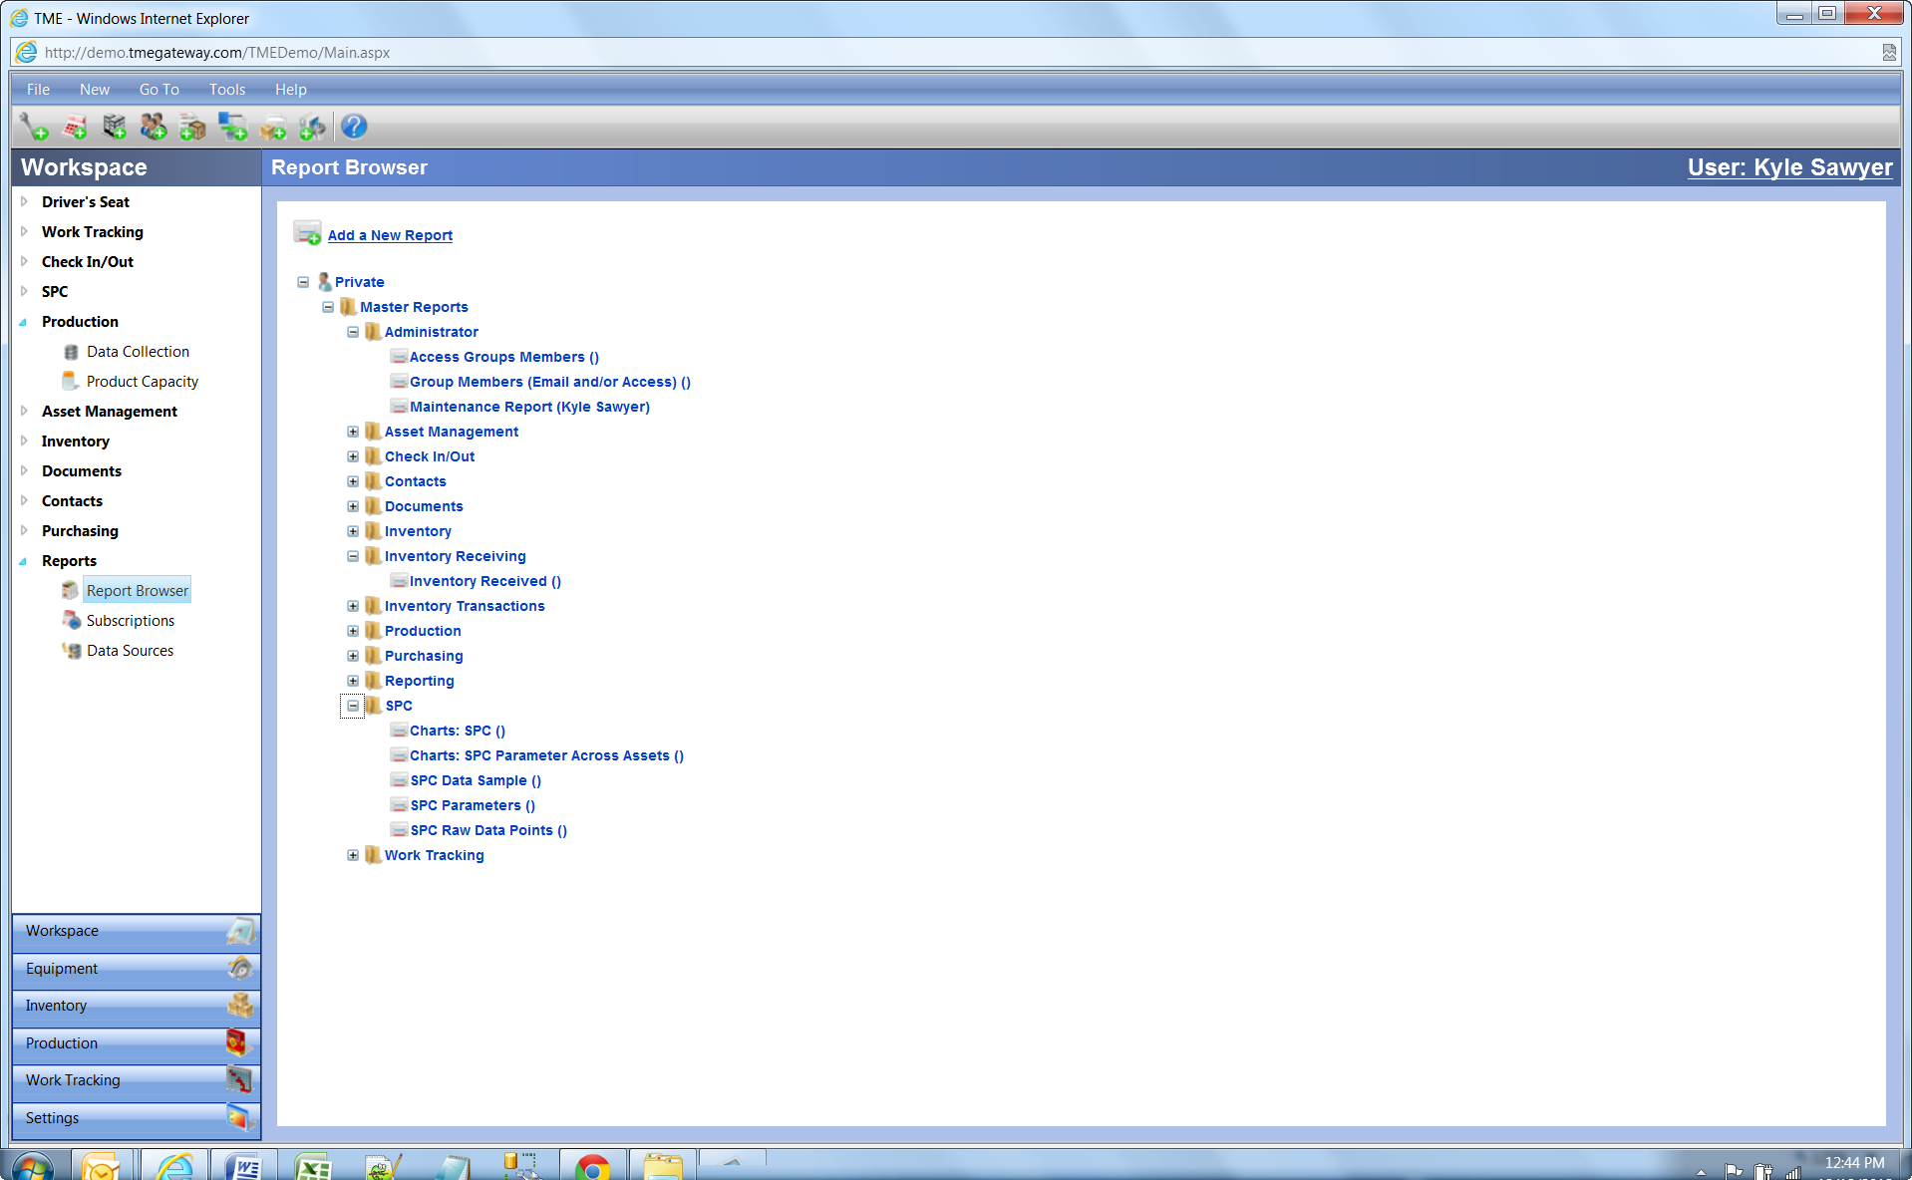
Figure 1 Report Browser

How to View a Report
From the Report Browser, click on the appropriate folders until the report title is visible. An open lock to the right of the title means that the User has permission to edit; a closed lock means that the User has read-only permission. Click on the title of the target report. This will bring you to the Webpage Dialog for this report if you have permission to edit (click the View Report icon on the Toolbar to continue to the Report Filtering Criteria) or directly to the Report Filtering Criteria if you only have permission to view.

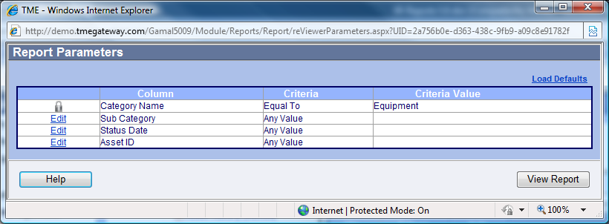
Figure 2 User Report Parameters Screen
Make criteria selections (see next section: How to Filter Criteria) and click . The report will generate within the same screen.
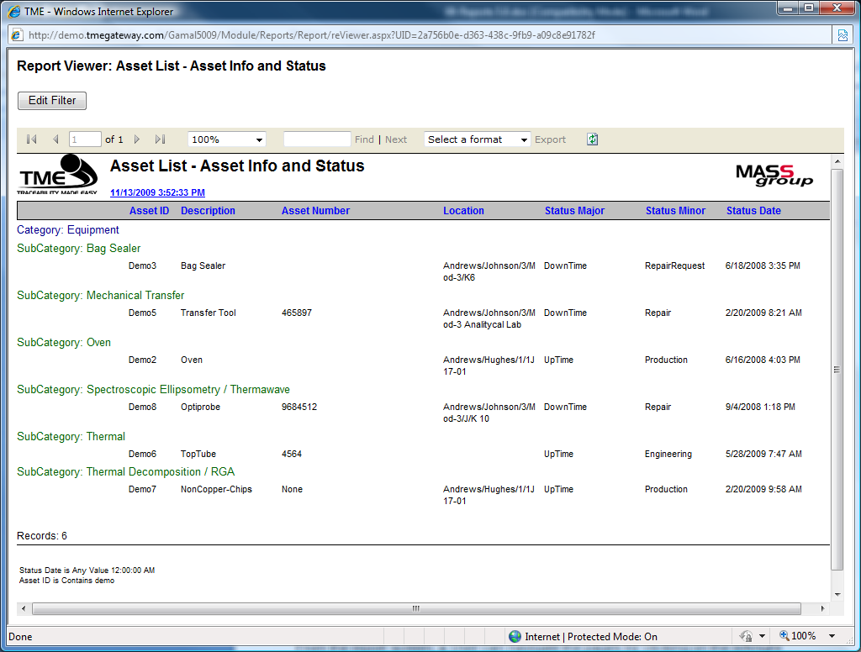
Figure 3 Example of a Report Rendered in Html
From the report screen, a User can navigate the pages by clicking on the left/right arrows or selecting a page number, select a percentage from the drop-down menu to change how large or small the type-print is, type in a word or expression and click the Find link in order to initiate a search (click the Next link to go to the next instance), export the report to pdf or Excel by selecting the format within the drop-down list and then clicking the Export link, refresh the report by clicking on the Refresh icon, print the report by clicking on the Print icon, redefine the criteria selections by clicking on the Edit Filter button, or click on the X at the top right corner of the screen to close the report.

How to Filter Criteria
Filter on a particular Report Column by selecting a Filter Criteria and entering a specific Criteria Value, much like how the Search tool is used throughout TME. A closed lock indicates that the filter is locked and can't be changed by the User. Click .
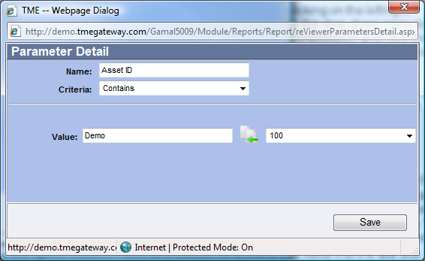
Figure 4 Parameter Detail Screen
Select the criteria such as "Equal To," "Less Than," "Contains," "Between," or "Begins With." Type in a Value in the first available text box or click on the arrow icon of the drop-down box to the right to select a Value and click on to move that value into the text box (see Appendix 2: Using a Variable Date Filter for more information on variable dates). To return the Filter Criteria to the default selections as originally designed with the report, click on the Load Defaults link. Click on . Click when finished selecting criteria to view the report.
Click on the arrows or type in a page number to navigate through the pages. Select a percentage from the drop down menu to change how large or small the type-print is. Type in a word or expression and click in order to initiate a search (click to go to the next instance). To export the report to PDF, Excel or Word, select the format and click.

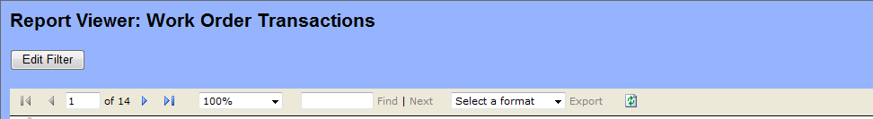
Figure 5 Report Viewer Toolbar

To change the report filtering criteria, click , reselect the criteria and click .

How to Create/Edit a Report
New reports can be added by clicking on above the Reports Tree within the Reports Browser. To edit a report, click on the appropriate folders until the title of the report appears and double-click on the title to open the Details screen.

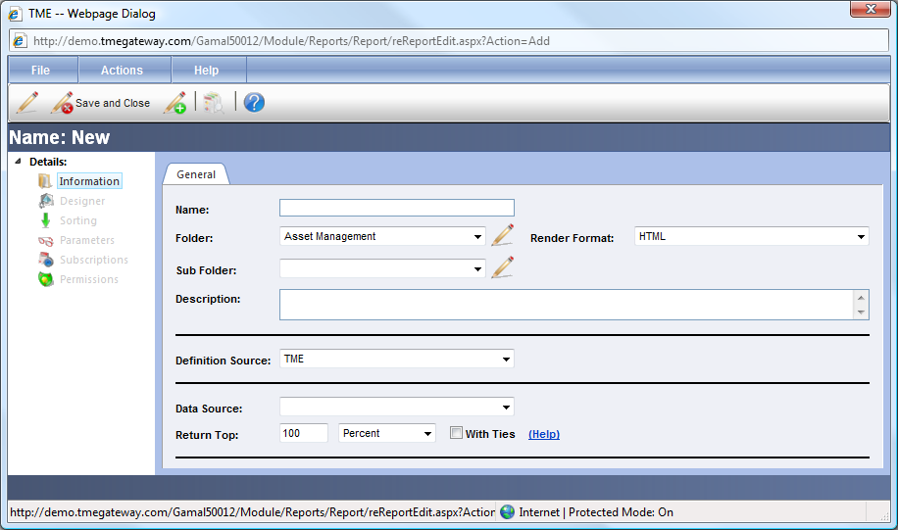
Figure 6 New Report Detail Screen
If creating a new report (if editing, change information as needed), type in the name of the report, select a folder and subfolder (or click on to type in a new folder and subfolder name--subfolder is not required and may be left blank), select the Render Format: Data, Excel, PDF or HTML, select the definition source (TME is the internal source or you may select Imported to import an Rdl file), and select the Data Source. .
Select the top percentage or number of records the report is to show. That is determined by which field is first selected to be sorted in ascending or descending order. For instance, to create a report to show the 10 most expensive work orders, the report needs to first be sorted in descending order by Total Cost with the selection of Return Top: 10 Records. Selecting the checkbox “With Ties” means that additional rows will be returned with the results if the values defined in the sort columns are the same as the values contained in the last record returned by the Top XX Percent/Records limit. In this example, if there is a tie for the tenth and eleventh most expensive records, 11 records will be visible if With Ties was selected.

Report Detail Links

Designer

Designer sets up the basic formatting, grouping and columns of a report. To set up, click on the Designer link in the menu of the report's Detail Screen.
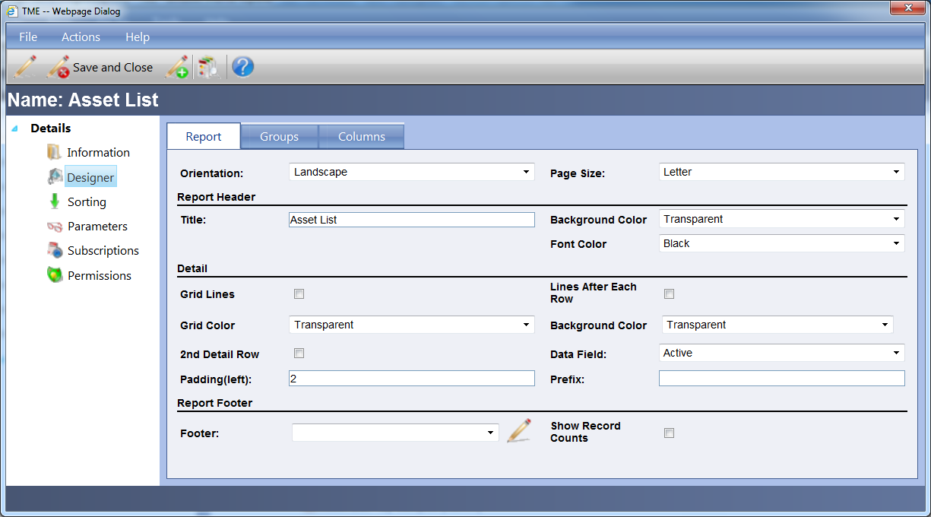
Figure 7 Report Designer Screen
- Report Tab
Section 1, Orientation: Select Landscape which sets the report to 8.5" tall and 11" wide or Portrait which sets it to 11" tall and 8.5" wide for Letter size. Select the Page Size: Letter or Legal (8.5" x 14" for Landscape, 14" x 8.5" for Portrait).
Section 2, Report Header: Type in the title of the report as it is to appear at the top of each page; select the Background Color and Font Color of the column header.
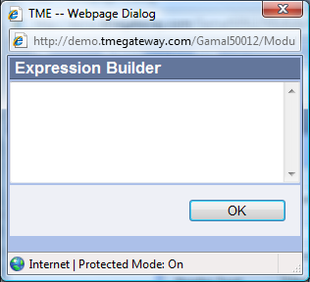
Section 3, Detail: Click on the checkbox for Grid Lines if the column and row lines are to be visible and select the Grid Color of those lines. Click on the Lines After Each Row checkbox if only the lines after each row are to be visible (color of the lines will be black). Select the Background Color of the body of the report--the color may be based on a Microsoft Reporting Expression (select ::Expression:: instead of an actual color, click on , type in the expression within the Expression Builder popup screen, and click OK to save).

Figure 8 Expression Builder Screen
Click on the checkbox for 2nd Detail Row along with which Data Field that 2nd row will show (i.e., Comments could be set as a second row for every row of data in a report). The 2nd Detail Row will span the length of all of the columns in the report.
Section 4, Footer: Select the Footer from the drop-down list or click on to type in a new footer. Click on the checkbox for Show Record Counts if the number of records for the entire report is to be listed in the bottom left corner of the report.
2. Groups Tab
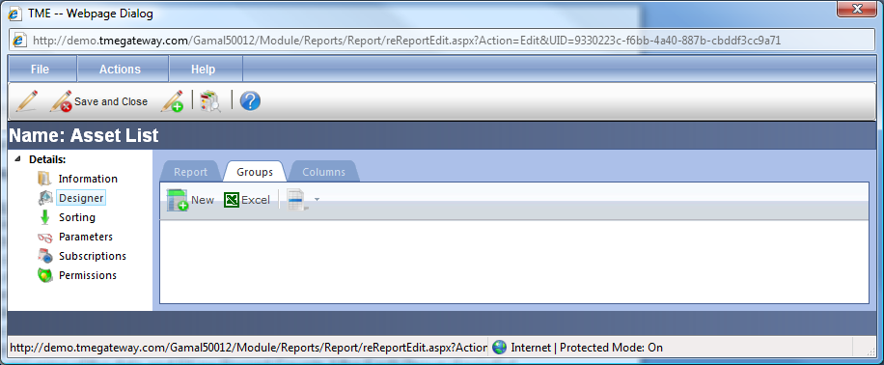
Figure 9 Report Designer - Groups Screen
Section 1: Click to add a Group or double-click on (or right-click and select View) the row of an existing group to edit.
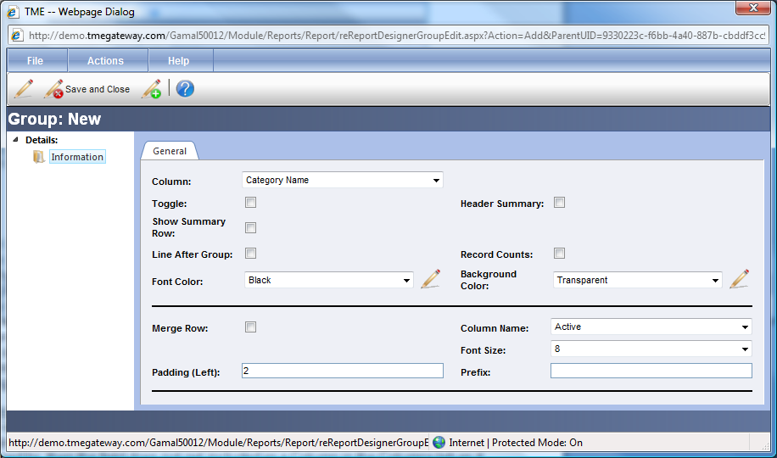
Figure 10 Report Group Detail Screen
Select the field in the Column drop-down list by which the report data is to be grouped (Note: the column does not need to be included as a column on the report--a report for example can be grouped by Category and not have the categories listed). Check the Toggle checkbox if the data is to be expanded and minimized on the Group field and if so, select the checkbox if there is to be a Header Summary (provides a summary of the data for that group in a group header). Select Show Summary Row if there is to be a summary of the data in a row after each grouping. Select Line After Group if there is to be a line across the screen/page after each grouping of the data and Show Record Counts After Each Group if needed. Select the font color of this field and the background color of the Group's row.
Section 2: If the Group header row is to extend across the entire report, select Merge Row and the corresponding Column Name (usually the same as the column to be grouped by, but can be different). If the Column Name is the same as the column to be grouped by, then the field does not get included as a Column in the Columns tab as it will already be displayed on the report. Select the font size and type in an alternate left Padding (based on point size) to increase or decrease the indentation of the Column Name. If a prefix attached to the Column Name is desired (i.e., "Category:"), type the text in the Prefix field.
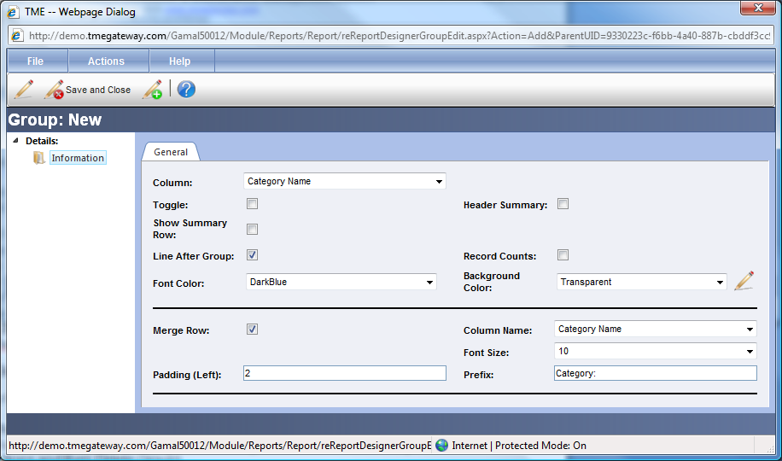
Figure 11 Report Group Detail Screen
Save and Close.
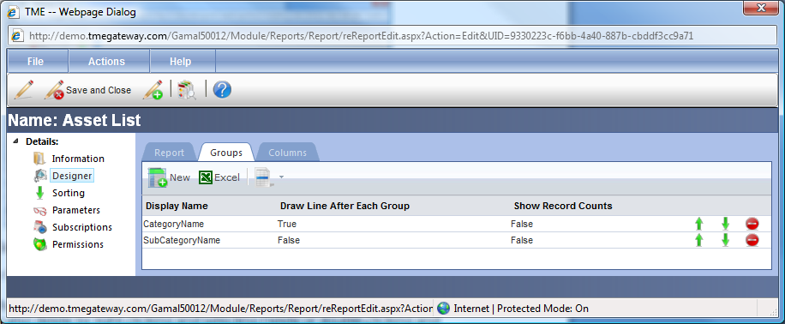
Figure 12 Report Groups Viewer
Click on or arrow icons to change the order of the groups as they are to appear on the report. Click on to delete a group straight from the Viewer (can also delete by right-clicking and selecting Delete or double-clicking and selecting Actions and then Delete Group).
- Columns Tab
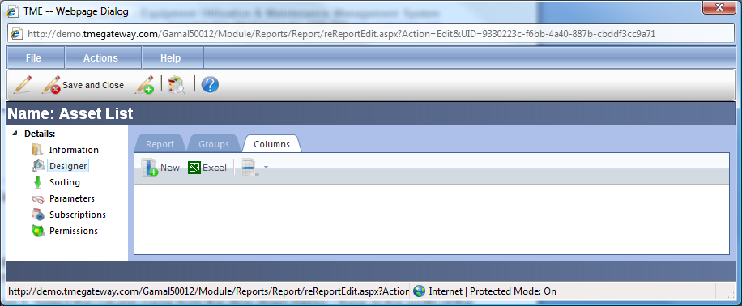
Figure 13 Report Designer - Columns Screen
To add a new column, click on . To edit an existing column, double-click it (or right-click and select View).
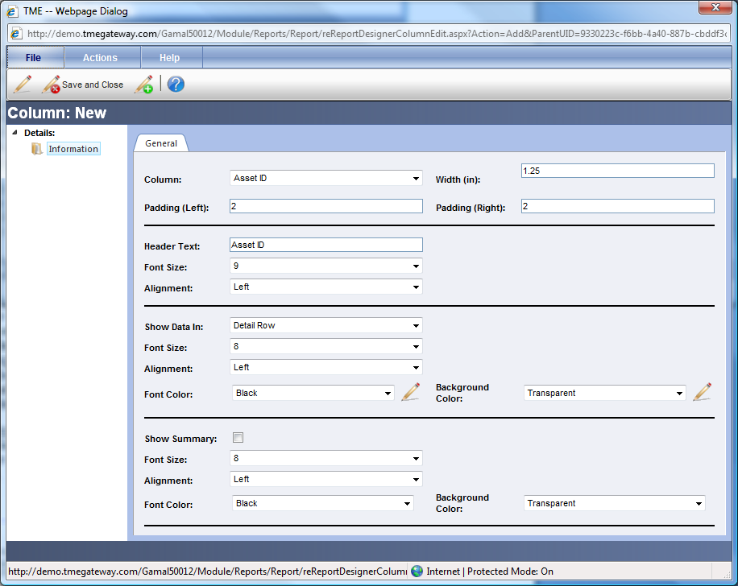
Figure 14 Report Column Detail Screen
Section 1: Select the column name from the drop down menu. Type in the width of the column in inches (to export to PDF and have all columns print on a single page, make sure the widths of all of the columns sum up to less than 7.5" for portrait and 10" for landscape). Type in alternate Left and/or Right Paddings (based on point size) if more or less space is needed on either side of the column title and data.
Section 2: Type in the Header Text if it is to be different from the column name and make the font and alignment selections as applicable. The Font Color of the data text and Background colors of the column may also be changed using the drop-down lists. The Font and Background Colors may be based on a Microsoft Reporting Expression (select ::Expression:: instead of an actual color, click on , type in the expression within the Expression Builder popup screen, and click OK to save).
Section 3: In the Show Data In drop down menu, select if the column is to appear in every row (Detail Row) or in the title row (name of Group) for the group. Make the font size and alignment selections as applicable. For data that is numerical or a date, select the data format and number of decimal points if applicable. Select the Font Color and Background Color for the data in the column as well. As with other sections, the Font and Background Colors can be based on a Microsoft Reporting Expression.
Section 4: If a summary is possible with the chosen column, a fourth section will be available allowing the selection of Show Summary. The Font Size, Alignment, Font Color and Background Color may be selected separately from those chosen for the data. As with other sections, the Font and Background Colors can be based on a Microsoft Reporting Expression.
Save and Close.
Click on or arrow icons to change the order of the columns as they are to appear on the report. Click on to delete a column straight from the Viewer.

Sorting
Sorting sets up how the report information is to be sorted.
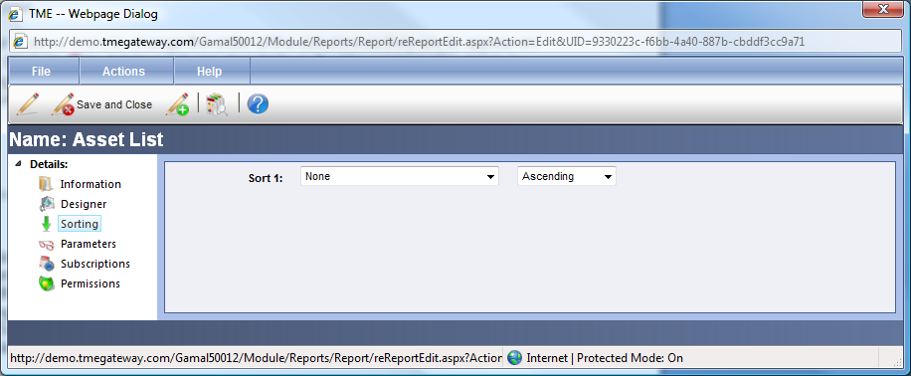
Figure 15 Report Sorting Screen
Select the first column by which the report is to sort from the Sort 1: drop down menu. Select Ascending or Descending. The Sort 2: drop down field will appear—make a selection if there is to be a second sort and the Sort 3: drop down filed will appear. Keep making selections as needed (sorting will take place in the order of columns selected). To change a Sort, select a different column in the corresponding drop-down field. To delete a Sort, select “None” from the drop down field.

Parameters

Parameters set up the criteria by which to filter a report.
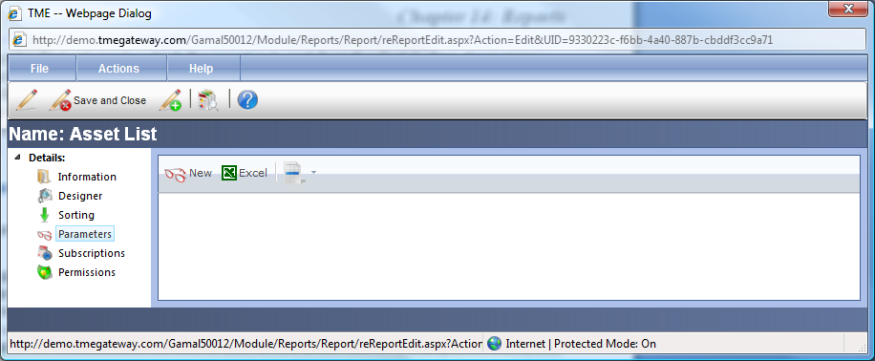
Figure 16 Report Parameters Screen
To add a new parameter, click on . To edit an existing parameter, double-click it (or right-click and select View).
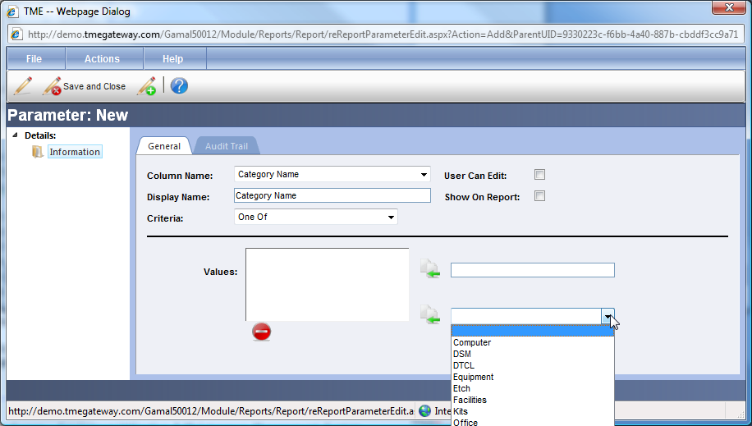
Figure 17 Report Parameter Detail Screen
Select the Column Name, Display Name and Criteria such as “Equal To,” “Less Than,” “Contains,” “Between,” or “Begins With.” Type in a Value in the first available text box or click on the arrow icon of the dropdown box to the right. select a Value and click to move that value into the text box. Click the corresponding check boxes if the User of a report may edit the parameter and whether or not the parameter selection will be printed at the bottom of the report. Save and Close.
Click on or arrow icons to change the order of the parameters as they are to appear on the report. Click on to delete a parameter straight from the Viewer.

Subscriptions

Subscriptions are the scheduled sending of Reports on a Daily, Weekly, Monthly, or Annual basis. The TME Runtime Engine will compile the report with up-to-date data on the day scheduled and will forward to the recipients via email, file onto a server or send to a printer. The Runtime Engine is usually set up to run in the early morning hours (1-2am). The TME Administrator will be able to verify the time that is set up and make adjustments if necessary.
To set up a Subscription, click on .

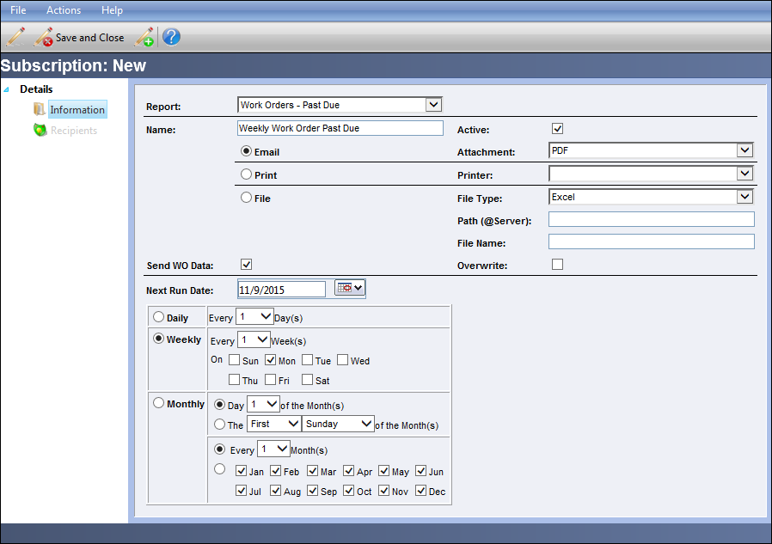
Figure 18 Subscription Detail Screen
Select the report to be scheduled, type in a name for the subscription and check the checkbox if the subscription is to be active.
Select the radial button for either Email, Print or File accordingly. For Email, select the Attachment type: Excel or PDF. For Print, select the Printer (if Printer is not available in the drop-down list, see TME Administrator). For File, select the type: Excel or PDF; type the path that has been already set up on the Server (example: C:\Metrics\Daily); type in the name of the file; select the Overwrite checkbox if the file is to be overwritten each time the runtime engine is run (if not selected, a new file is saved with a timedate stamp as part of the file name).
Select the checkbox for Send WO Data if the report is to be delivered even if there is no data in it. If not selected, reports without data will not be sent.
Set the Next Send Date (make sure it is not the current date as most likely the runtime engine has already run) and the schedule. Save. The additional link, Recipients, will appear (will already be visible if editing) in the menu on the left if the Email radial is selected.
Click on the Recipients link to select who will receive the report.
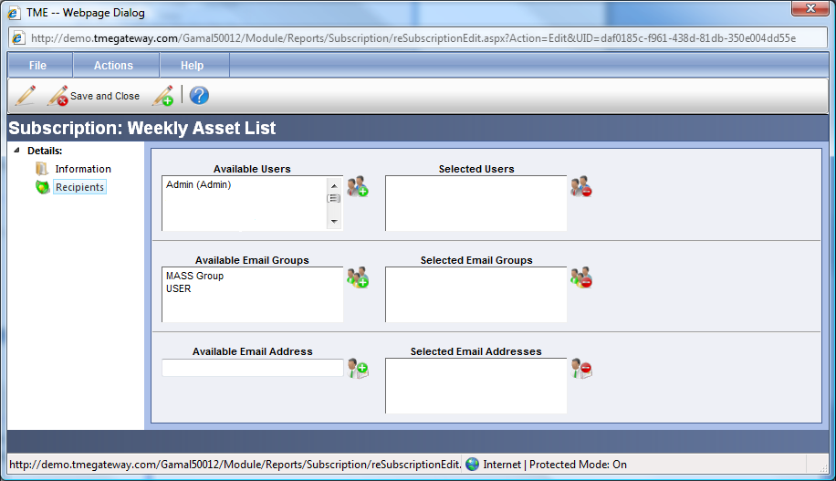
Figure 19 Report Subscription - Receipients Detail Screen
Select a User (hold the Ctrl key if making multiple selections) from the Available Users field within that section and click on . The User(s) selected are now visible in the Selected Users field. To remove a User from the Selected Users field, select the User (hold the Ctrl key if making multiple selections) from the Selected Users field and click on . The same process applies to adding and removing Email Groups. To include a recipient who is not a User within TME, type in his/her valid email address in the Available Email Address field and click on to the right of the field. The email address is now visible in the Selected Email Addresses field.
Save and Close.

To Activate/Deactivate a Subscription
Double-click on the Subscription title or right click on the row and select View. Select the Active checkbox to activate the subscription or deselect the checkbox to deactivate the subscription. Save and Close.

Permissions
Permissions to view and/or edit reports are based on individual Users or Access Groups. To set up the Permissions, click on the Permissions link.

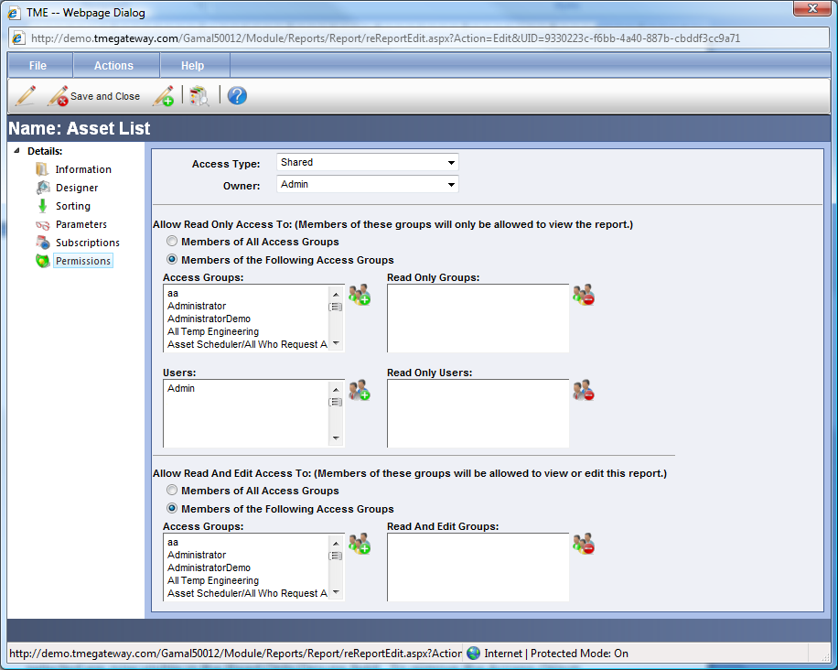
Figure 20 Report Permissions Screen
Select either Private or Shared for the Access Type. Private means that only the owner of the report will be able to view it and that this report will be located in the Private folder of the owner. Shared will allow others access to the report and it will be located in the Shared folder of only those provided with access.
Select the Owner of the report if it is not to be the creator of the report. If the Access Type remains Private and the ownership is changed to someone else, the creator will no longer have access to this report.
Once the Access Type is changed to Shared, additional fields for granting access are opened up.
To allow Read Only access to specific Access Groups, select the Access Groups and move them into the Read Only Column Group. The same process applies to adding and removing Users.
To allow Read and Edit access to specific Access Groups, select the Access Groups accordingly.

Copy Report
To copy a report, click on the report to be copied. Click on Action on the Detail Taskbar and then Copy Report. The report that was originally opened to be copied will close and the copy's Detail screen remains open. Edit the name of the report on the Information screen and the title of the report on the Designer screen (Report tab). Make further adjustments as required. Save and Close.

View SQL or RDL
The RDL is the formatting code while the SQL statement determines what data is to be included in the report. The purpose of having this code viewable is so that Users who are familiar with either can use them to debug the report if there are issues. From the report's Detail Screen, go to Actions and then Show RDL or Show SQL. A popup screen with the appropriate information will appear.

Exercise 1:
 Create a Report that looks like the following screenshot:

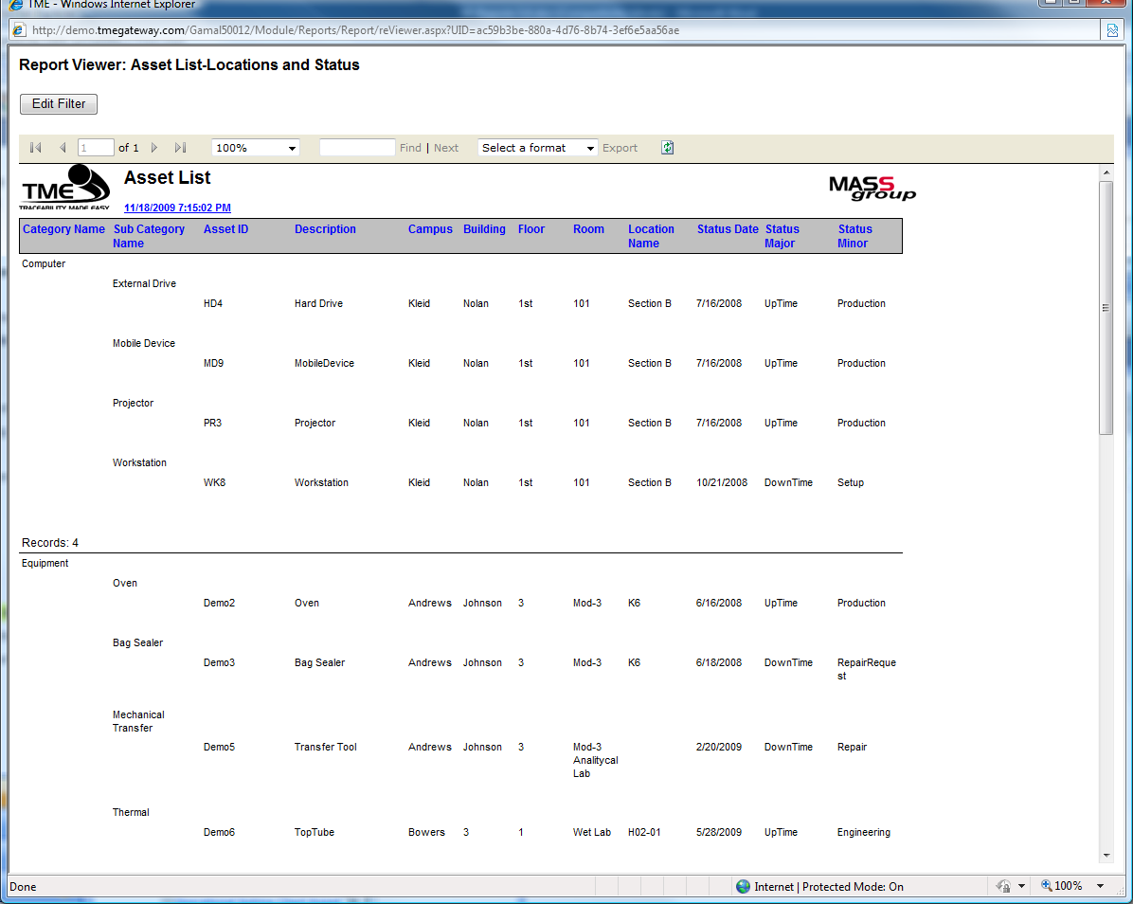
Figure 21 Example of Report to Replicate
Exercise 2:
Set up a weekly subscription of the report to yourself and an email group.

Exercise 3:
Create a Report that looks like the following screenshot:

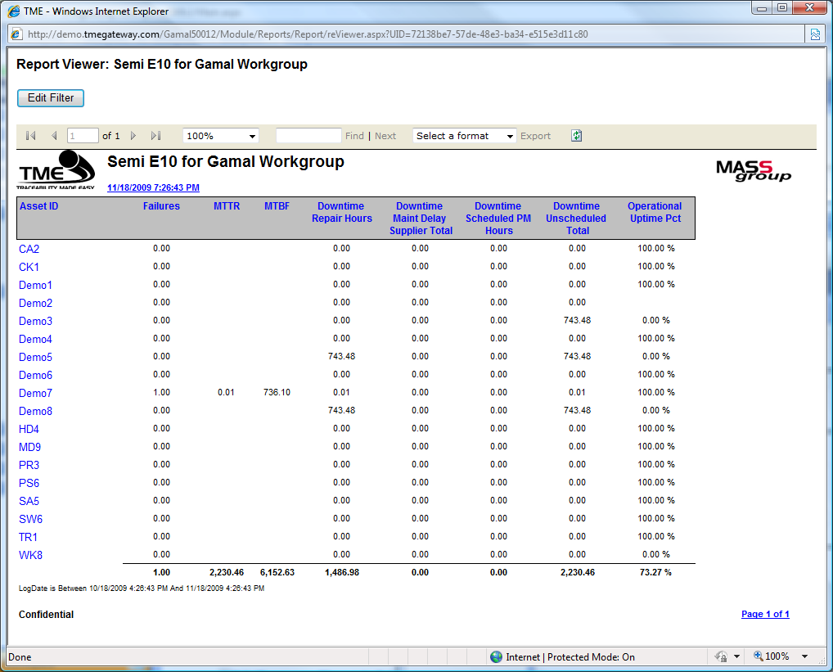
Figure 22 Example of Report to Replicate

Exercise 4:
Set up the Semi E10 report as a shared report with permission granted for viewing only by the other training participants.

